Quick-Commerce Location Intelligence & Expansion Strategy
A geospatial decision-support system for identifying high-potential dark-store expansion locations in India.
Tech Stack: Python • Pandas • GeoPandas • OpenStreetMap • Plotly • Geospatial Analytics

Project Snapshot
4,081 Dark Stores | 3 Brands | 3,232 Decision-Ready Locations | 48 Markets | 12 Expansion Markets
The project analyzes Blinkit, Zepto, and Swiggy Instamart to identify markets where strong consumer demand meets available competitive whitespace.
Situation
Quick-commerce expansion is expensive, and choosing a location based only on population or demand can lead to entering an already saturated market.
The real business problem was:
Where should a quick-commerce brand expand next while avoiding excessive competition?
The analysis therefore considered demand, competition, brand strength, store density, and local environment together.
Task
The goal was to build a location intelligence system that could:
- Measure market demand and competitive pressure.
- Identify untapped competitive whitespace.
- Rank markets by expansion potential.
- Classify them as EXPAND, WATCH, or LOW PRIORITY.
- Evaluate a specific Indian location through an interactive engine.
Action
Market & Demand Intelligence
Combined 4,081 dark-store locations: 1,954 Blinkit, 1,089 Zepto, and 1,038 Swiggy Instamart stores.
A Retail Demand Index was used instead of population alone. Bangalore (0.901), Pune (0.878), and Mumbai Suburban (0.877) emerged among the strongest demand markets.
Competition & Opportunity Intelligence
Local competition was measured using competitor pressure, brand share, and store density.
The core principle became:
Strong Demand + Competitive Whitespace = Expansion Opportunity
Opportunity Scoring
A Location Opportunity Score / 100 combined:
40% Demand • 20% Competition Opportunity • 15% Competitor Pressure • 15% Brand Strength • 10% Density
This produced 3,232 decision-ready locations, with rankings tested under different strategic priorities for greater reliability.
Results
From 48 evaluated markets:
- 🟢 12 EXPAND
- 🟡 12 WATCH
- ⚪ 24 LOW PRIORITY
Coimbatore ranked highest in the baseline model, while Madurai showed particularly strong ranking stability.
The main finding was simple:
High demand does not automatically mean high expansion potential. Competition determines how much of that opportunity is actually available.
Final Output — Interactive Location Intelligence Engine
The analysis was converted into an interactive decision-support tool.
A user enters a location or coordinates, brand, and search radius, and the engine returns:
Site Score • Demand • Market Opportunity • Nearby Stores • Competitors • Whitespace • Strategy • Reliability
This turns the project from a static analysis into a practical first-stage site screening system for quick-commerce expansion.
Business Value
The framework narrows a complex location decision from:
4,081 stores → 3,232 scored locations → 48 markets → 12 expansion priorities → site-level recommendations.
Its purpose is not simply to find where demand exists, but to identify where commercially attractive demand is still available.

Case Study — Pachora Expansion Opportunity

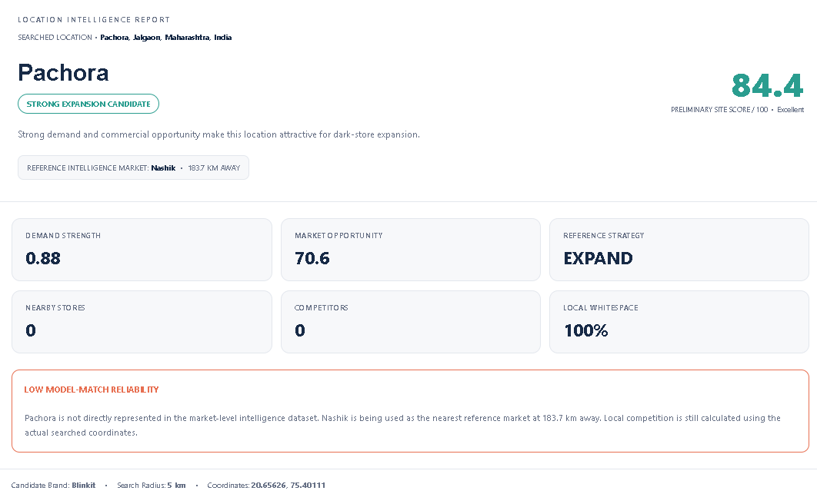
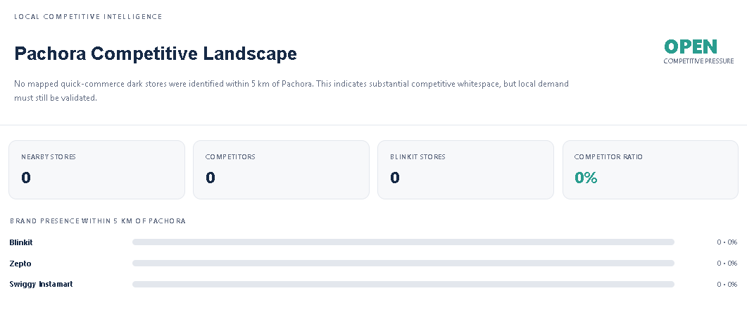
The model evaluated Pachora, Maharashtra for Blinkit and generated a site score of 84.4/100, classifying it as a Strong Expansion Candidate.
With 0 nearby competitors and 100% competitive whitespace, Pachora shows strong first-mover potential. However, since the demand estimate uses Nashik (183.7 km away) as the reference market, the result has low model-match reliability.
Outcome: 🟢 High Potential — Shortlist for local feasibility validation.

Case Study — Mumbai: High Demand, High Competition

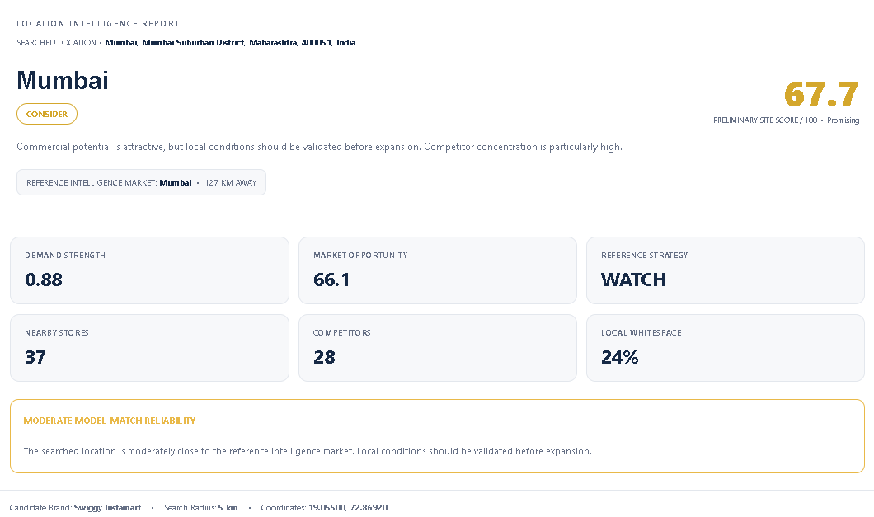
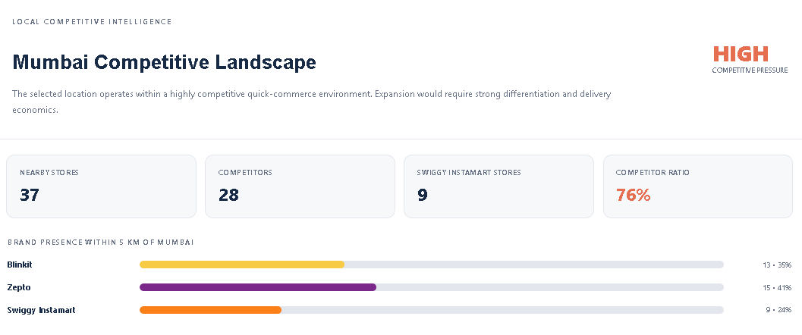
The model evaluated Mumbai for Swiggy Instamart and generated a site score of 67.7/100, classifying it as CONSIDER / WATCH.
Despite strong 0.88 demand strength, the 5 km radius contains 37 dark stores, including 28 competitors, resulting in a 76% competitor ratio and only 24% local whitespace.
Outcome: 🟡 Promising Market, but high competition makes expansion riskier — validate carefully before expansion.

